Digital Design

CSCE 2114-L007

Blake Fasse

April 4, 2017

[bafasse@uark.edu](mailto:bafasse@uark.edu)

**Introduction**

In this lab VHDL code had to be written in order to make a 7-segment display to display numbers between 0 and 9 and letters A through F. In order to display a character a string of seven numbers that are either 0 or 1 is used with a 0 turn the LED of the display on and 1 to turn the LED off. For example, to display an A on the display the switches on the FPGA board need to be set to 1010 and the code to display that character are 0001000.

**Design**

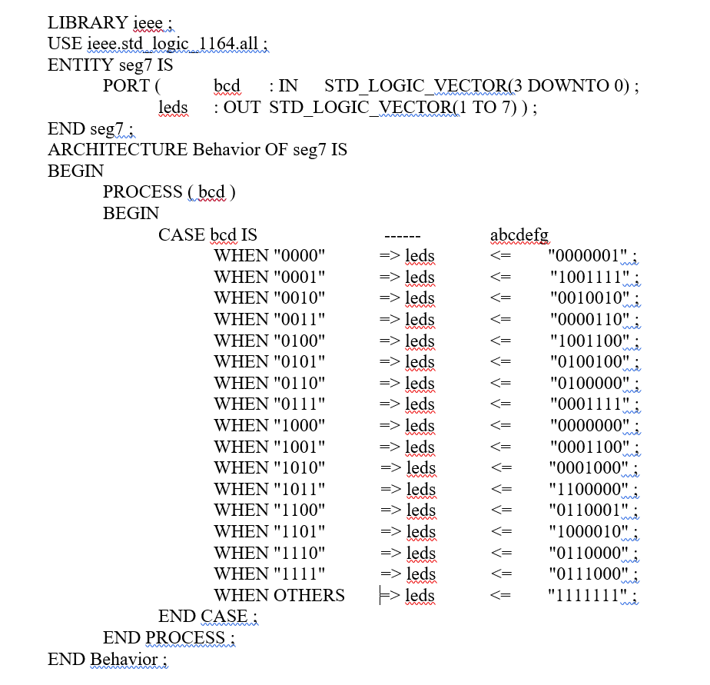Since there are four switches that represent either a 0 or a 1 then there are a total of 16 inputs. VHDL sample code was given in the lab document that would display numbers 0 through 9 on a 7-segment display with a 0 turning the LED on and a 1 turning the LED off. The goal of the lab was to write the remaining six inputs to display characters between A through F with any other input displaying nothing. A picture of the VHDL code and the 7-segment display is displayed below.

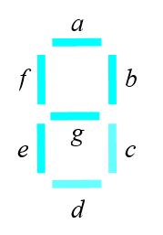

**Results**

The complete code that will display numbers 0-9 and letters A-F are shown above. On the right is a string of numbers either 0 or 1 and each number in the string corresponds to a letter on the 7-segment display. The lab was able to be completed in no time with no hindrance to speak of. Upon completion, it was shown that the outputs on the 7-segement display were hexadecimal values so in a way this was a binary to hexadecimal calculator.

**Conclusion**

This lab gave an introduction to writing in VHDL and how to output that code to the FPGA board. Using VHDL allowed to make a program that when you flipped switches on the FPGA board that a 7-segment display showed either numbers 0-9 or letters A-F and the switches represented binary code while the output matched hexadecimal values.